****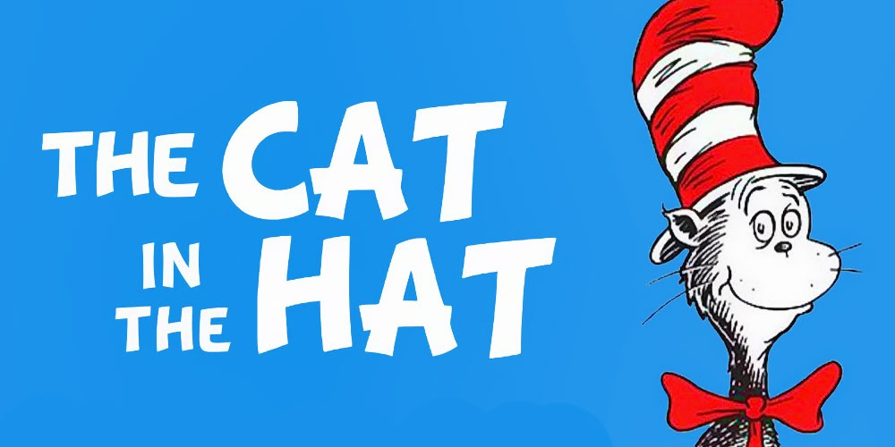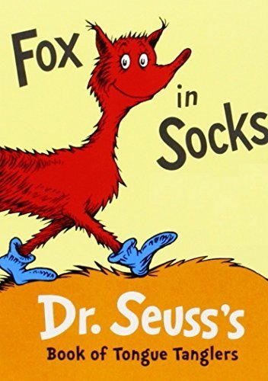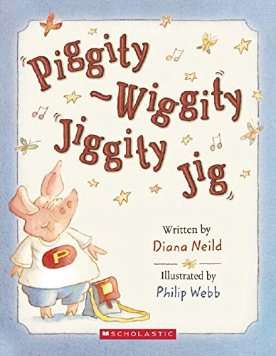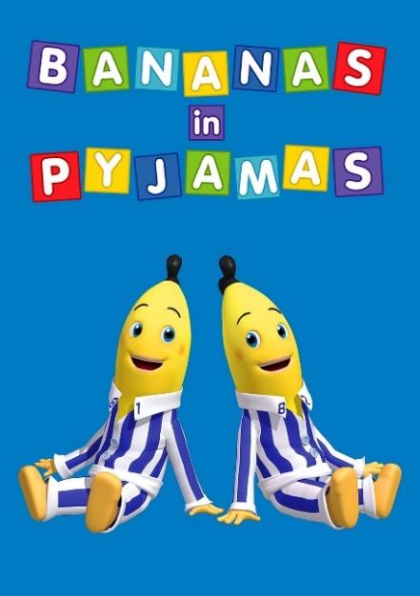

**Hand in by Friday 25th November**

**Judged by Miss Ivison**

**Winners announced at the end of Term**

**Poetry Competition  
Write a rhyming poem about a character you have made up!**

**Can you write a rhyming poem? It can be any length but needs to be about a character.**

**For example…**

**‘Bananas in Pyjamas’**

**‘Cat in the Hat’**

**‘Angelina Ballerina’**

**‘Little Miss Muffet’**

**'Hairy McLairy from Donaldson's Dairy'**

**…are all rhyming poems about a character.**

**You decide what it is about and who the character is. It can be short and sweet.**

**Have fun!**