How do I format my story?

- Please ensure you write your story on Word (or cut and paste on to a Word document if you use Pages). We cannot accept stories written on Pages.
- Checking word count: On Word, there is a word count always present on the bottom left of the screen.
- Name your document with your first name and last name (and not ‘My Short Story’ or ‘Draft 5’ or ‘Final draft’). This is good practice for naming any document, especially ones you email to teachers.

- You can change the font here, the font size here (14 is too big) and the spacing here

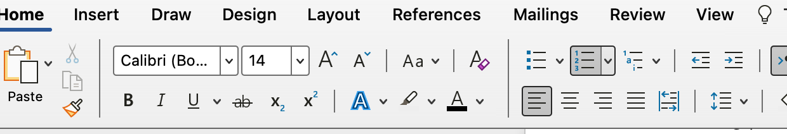

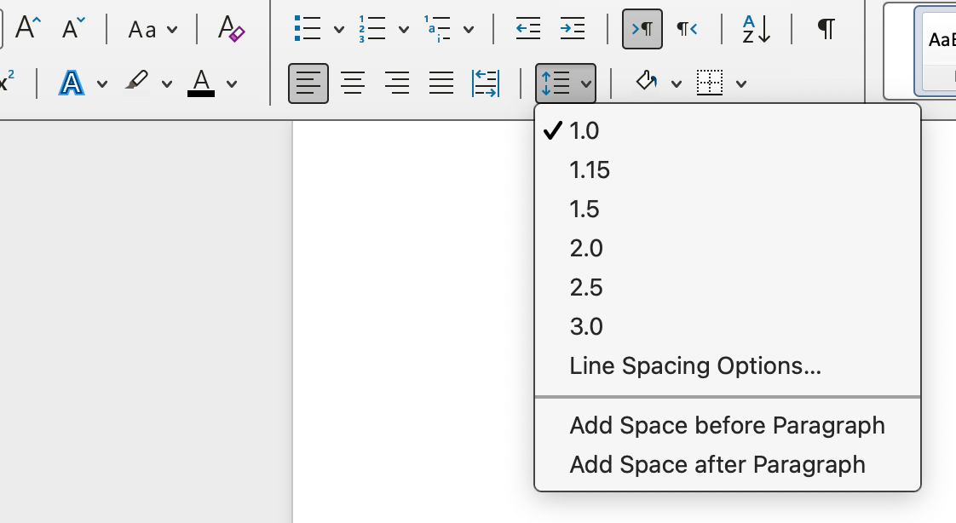

- Indenting dialogue and new paragraphs:
On a Mac: Go to Format/Paragraph then Indentation Special

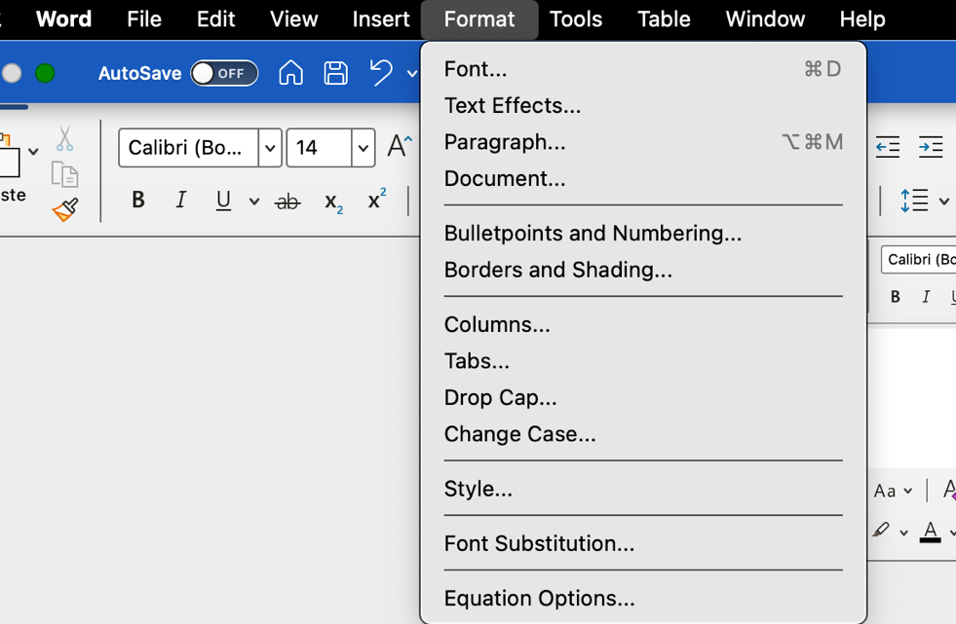

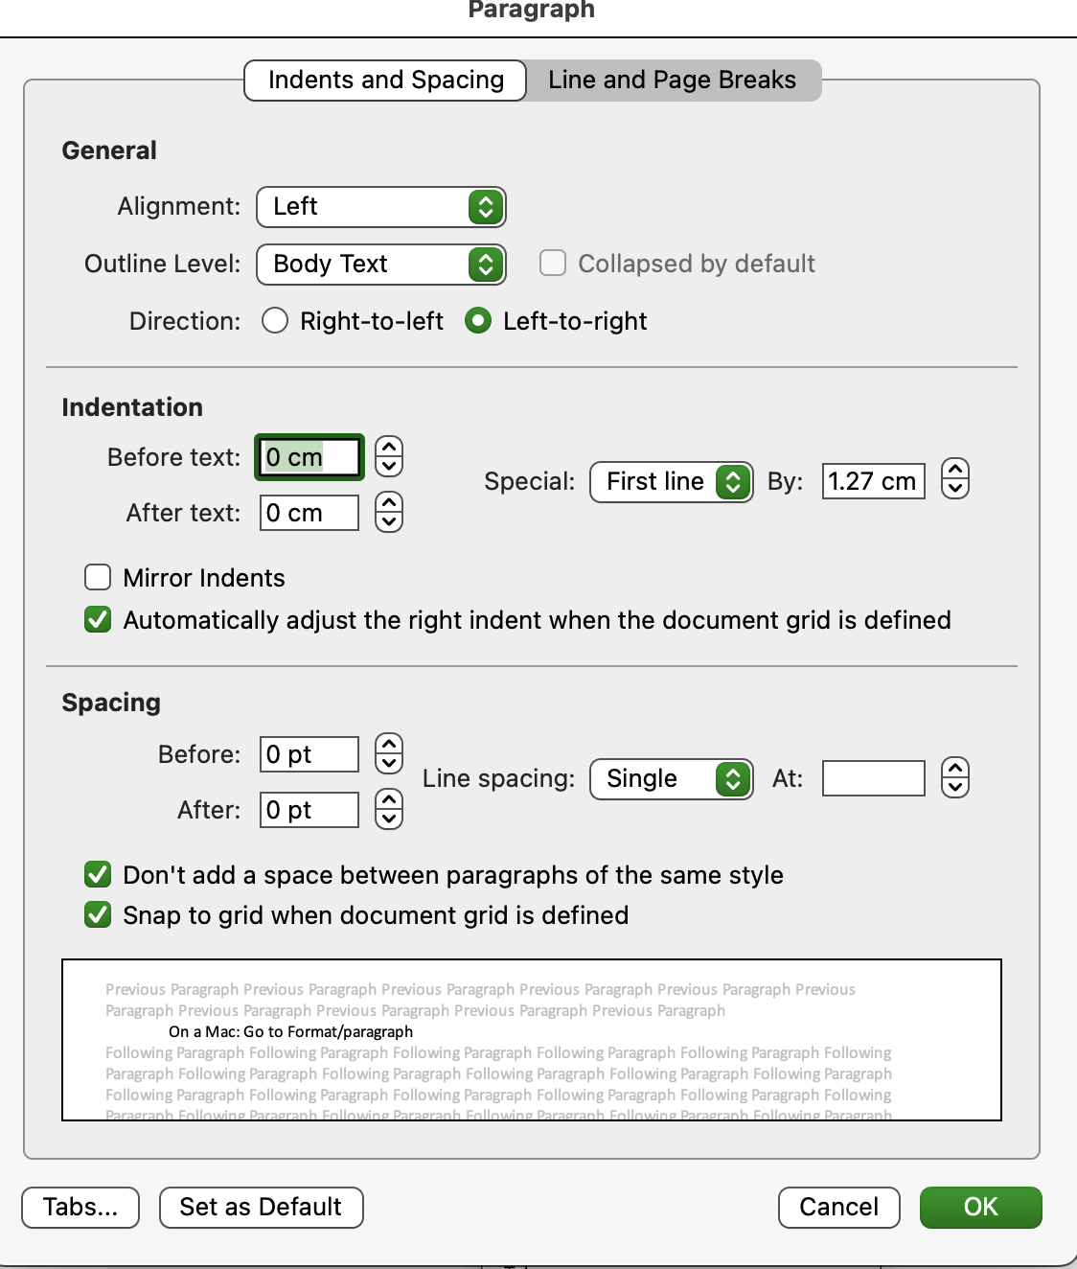

On a Surface:

- On the Home screen, click this buttony arrow thing next to Paragraph
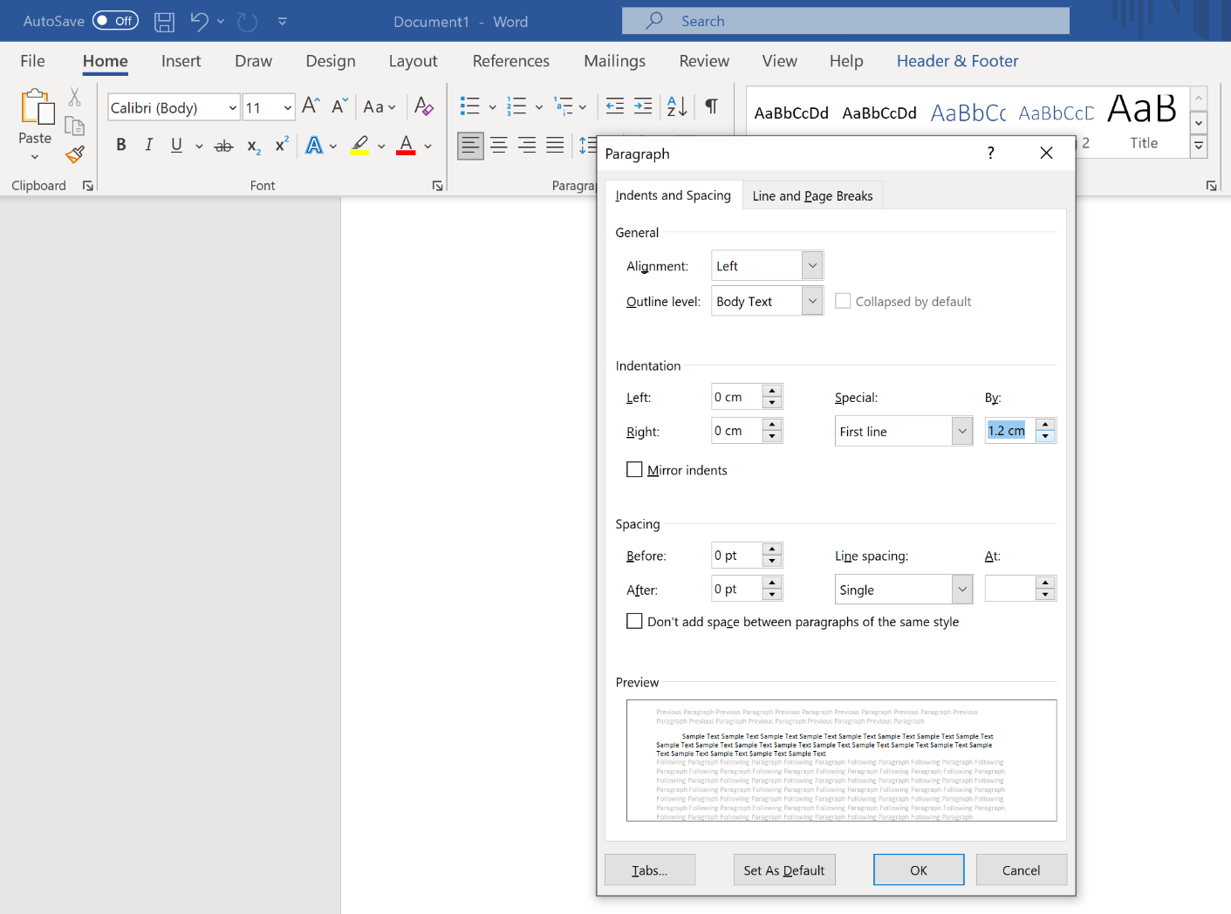
- Choose First line and 1.2 or so from the drop down menus.

- Adding page numbers.
On a Mac: go to Insert/Page Numbers

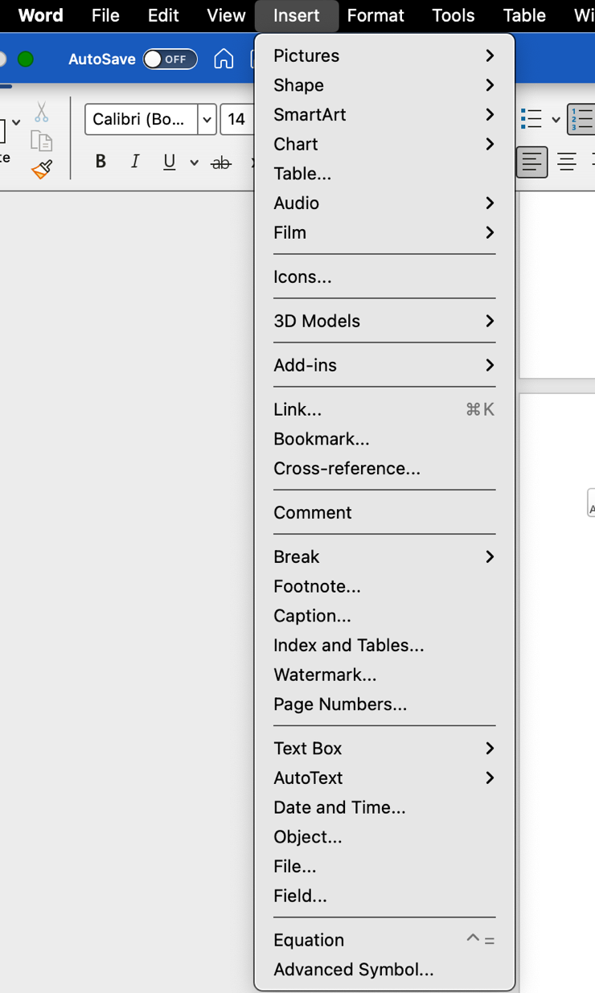

On a Surface: Go to Insert and then Page Numbers

