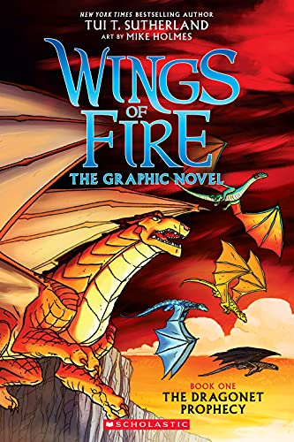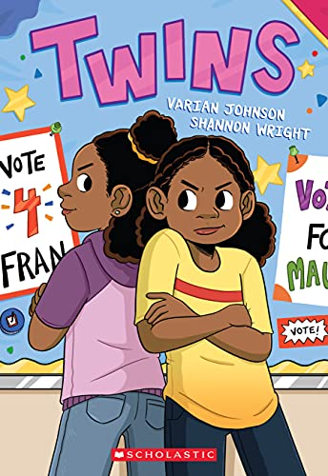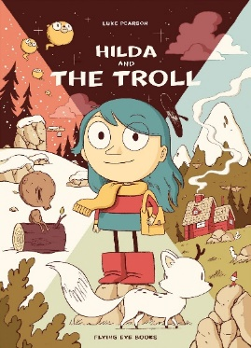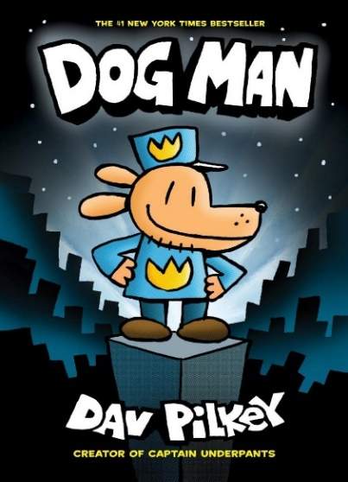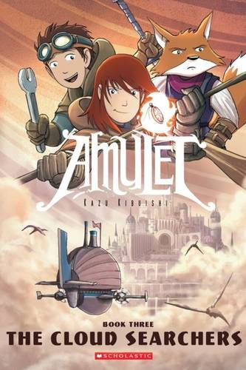

**Graphic Novel or Comic Competition:   
design your own cartoon!**

**Can you create your own graphic novel or comic strip?**

**Comedy, fantasy, action, realistic – you decide!**

**Make sure it is a great story with interesting characters.**

**Have fun!**

Han**d in by Friday 25th November**

**Judged by Miss Ivison**

**Winners announced at the end of Term**